Using the internet in the language classroom

Overview
In our presentation we would like to show how the internet can be used effectively to create lessons that do make a difference. There are several advantages of using the net in the language classroom. Some of the most important ones are:
- It is a contemporary way of learning.
- It is easy to bring authenticity into the classroom.
- It usually reflects the world of most of our learners better than the “traditional” classroom.
- Materials become re-usable and sharing among colleagues becomes easier.
- It encourages learner autonomy.
- Both teachers and students are more careful when editing materials for the web.
Working with the internet certainly does not save time, especially not at the outset and it can be frustrating at times to have to register for many services, although they are free, only to find out that they have already disappeared when trying to log in the next time.
However, we are convinced that the advantages by far outweigh the disadvantages. We both enjoy working with the internet and we recognize this joy in lots of our students.
Currently web 2.0 is the talk of the town. We are going to show how some of the web 2.0 technology can be used in the classroom.
- We will start with a short video taken from Youtube. Youtube certainly is a great resource when it comes to language materials.
- Next we’ll introduce two typical web 2.0 applications to you: polldaddy and skrbl: polldaddy is a free service that creates powerful surveys and polls, skrbl.com lets you use the internet as a collaborative whiteboard.
- Then we’ll show how blogging can be used to create interactivity and keep records of classroom activities like field trips or book reports and helps with documentation in various ways.
- Finally we will introduce vokis to you, which are animated characters that can be “equipped” with your real voice.

Polldaddy and skrbl

POLLDADDY
Polldaddy is a free service with which you can create surveys and polls. They can be created and edited on the internet and the results are also saved in your account on the website.
Polldaddy: http://www.polldaddy.com
Some suggestions for classroom use:
- Create a survey about students’ interest at the beginning of the school year.
- Create a poll if you want to decide which book to read, film to watch, etc. in the upcoming semester.
- Students create surveys themselves and encourage other classes to fill them in.

Skrbl - Whiteboarding and mindmapping
When taking notes and organizing your thoughts, nothing can be more helpful than whiteboarding and mindmapping tools. Mindomo is an online mindmapping tool, which makes beautiful representations of your mental map. The program is compatible with a number of offline tools, e.g. with MindManager from Mindjet.
Skrbl works like a whiteboard. It enables anyone who has the address of a specific web address to write at the same time. The results can be printed out or kept in your account for reference. Skrbl is a great tool if you work with a notebook class.
Skrbl: www.skrbl.com
Mindomo: http://www.mindomo.com/

Some suggestions for classroom use:
- Collaborative brainstorming a topic
- Writing down associations e.g. to a piece of art, music, etc.
- Taking notes
- Vocabulary work: word fields
- In notebook classes
- Introducing/ending a topic

Blogging
Blogs have been around for a number of years and their popularity is increasing. A blog is like a diary that is there for everybody to be discovered. Blogs are web pages that are easy to set up and where people usually write regularly about a topic that interests them.
Blogs are good to document recurring events, like a field trip over a number of days, or a book report that students give regularly. They are excellent when it comes to teacher – classroom communication. They are also good for processes, in which people need to be kept up to date regularly. Most often blogs are simply used by individuals to write about their hobbies or professional interests.
Blogger: www.blogger.com
Wordpress: www.wordpress.com

Some suggestions for classroom use:
- Using a blog for longer field trips, projects…
- Reading and rating blogs e.g. from different news sources
- Using it as a student portfolio
- Writing comments to “Have your say” pages: c.f. blog at http://news.bbc.co.uk/2/hi/talking_point

Voki – animating your voice
Voki enables users to express themselves on the web in their own voice using a talking character. You can customize your Voki to look like you or take on the identity of lots of other types of characters… animals, monsters, anime etc. Your Voki can speak with your own voice which is added via microphone, upload, or phone.
Voki lives on your blog, social network profile and will soon be integrated in various instant messaging platforms. You will also be able to download it to most video supported phones.
Voki: www.voki.com

Some suggestions for classroom use:
- Recording a voki for a web page, e.g. for a school
- Introducing yourself (e.g. to students of a partner school)
- Teacher speaking about her experiences with voki and how to integrate it into blogs http://participatecontributelearn.blogspot.com/2008/01/voki-in-wiki.html
- Voices of the world: project for younger students, in which they are asked to say “hello” in their language: http://votw.wikispaces.com/september%27s+task
Here are some more applications which offer language teachers a variety of options:

Video and Youtube
Youtube Videos are a great source for language classrooms. They provide a wealth of free videos from bad to excellent. Although there are quite a few ones which are clearly unsuitable for our purposes, there are still many, which can be used freely and purposefully. One suggestion when trying to find a video is to start out in the relevant category first, e.g. the news category, if you are trying to find something from a particular broadcasting station like ABC. While Youtube videos can be used like regular videos or DVDs and there is no new methodology involved, the simple advantage lies in the fact that there is a wealth of video material available and that shorter news bits do not need to be recorded and brought to the classroom. Youtube videos can be recorded, however, which means that you don’t depend on site an internet connection.
Examples on how to use youtube in the classroom
News stories
- Young Syrians to speak about stereotypes
- Inhalants to introduce the topic of drugs
- Hotel video to end a session on responsible traveling
- Hindu wedding video to speak about family and pre-arranged marriages
At the movies
- Students browse a movies podcast like the one from The New York Times. In groups of two or three students they choose a film and then watch the trailer. When finished they report about the film and give a recommendation, why the other students should/should not go and see the film.
- As a follow-up students can write a short film review of a film they have seen or read up about the film on the imdb. (http://us.imdb.com/)
Besides these videos, youtube is great to find videos on how things are done/made (how-tos), which can be used to e.g. describe processes. If you and your students have always wanted to be film producers, this is the perfect chance. It will improve students speaking skills and enhance their social behavior, since film making is generally a group process.

Photos from Flickr
If you have been looking for photos and images to use with your web pages you can use flickr. Their pool of images has many of which are licensed with a creative commons license, which means, you can use the photos freely as long as you follow certain terms, like mentioning the authors name.
Flickr is another community site. It caters for the community of photo aficionados. Flickr is host to a large number of amateur photographs, which can all add color and life to our projects and/or worksheets. It may sometimes be easier to just make your own shot, but if you are not such a sharp photographer, as it is the case with me, the site is perfect. Flickr allows you to browse through other people’s photo albums. Many pictures are licensed with a creative commons license, which means that you can use the photos freely under certain terms, like quoting the owner’s name and so on. On the creative commons site there is also a search engine, which can be used to search for photos under a creative commons license.

Moodle: Bringing it all together
Moodle is a learning management system (LMS) or course management system (CMS) - a free, open source software package, designed to help educators create effective online learning communities. You can download and use it on any computer you have handy (including webhosts), yet it can scale from a single-teacher site to a University with 200,000 students. A good start is to use the Moodle Demonstration Courses or if you are a teacher in Austria, you can try the edumoodle initiative to start your own classroom.
With Moodle can do the following things:
- Create a virtual classroom with integrated forum and messaging system for easy communication among teachers/tutors and participants, i.e. if you run a course with 30 students, you can see their profiles, track back their activities and communicate with them through various channels.
- Manage content: you can upload various files (documents, audio and movies…) and arrange or display them so that they suit your course. You can also have students upload their work.
- Create tests and assignments: electronic tests, which can be graded automatically, as well as hot potato exercises, which can be exported, can be used for testing purposes.
- Display podcasts: A block called “remote RSS” allows you to display podcasts so that the students can differentiate their own learning according to their levels of study. If for example an advanced student chooses the spotlight podcast (advanced) a less advanced student could choose something like “VOA Special English” podcast, where the speech is slower than native speaker speed.
- In Moodle you can also have chats and web links as well as display directories with e.g. different reading materials, categorized according to levels.
- With the integrated Wiki and blog functions you can have these two in a protected environment and don’t have to worry too much about spam or other manipulation.
Moodle is a powerful course management system, which helps to differentiate students’ learning and organize materials and communication in one place. If used well, the tool can engage all four competencies writing (wiki, blog, forum, chat), reading (course materials, forum, wiki) and listening (podcasts, integrated mp3 player for listening comprehensions) and speaking (audio forum). All well established functions in moodle system, except for the audio forum, which is still in development.
It takes a couple of hours to understand the basic concept of it but it doesn’t require any coding. It takes a sound concept and quite some time to set up a course for your students, this time could be equaled to the time it takes to prepare a lesson. So as a newbie it probably takes a little longer than as a routine “moodler”.

WIKIS
Wikis are web pages which allow easy editing. There are some free online wikis that cater especially for educational purposes. Wikispaces and peanut butter wiki are two example for free online wiki services.
Wikispaces: http://wikelearning.wikispaces.com/
Peanut butter wiki: http://pbwiki.com
Wikis are great for technical documentation or if you work on a collaborative research product. Work and collaboration as well as presentation can be shared easily.
Some suggestions for classroom use:
- If you work on a topic like “art of the 20th century” or “religions of the world,” you can set up a wiki in which students can work on different subtopics in groups. E.g. one group works on pop art whereas another group works on surrealism. The task can be either very open, like above, or more specific. In the latter case you could e.g. direct students to specific websites.
- Wikis can also be used to share lesson plans with your students. A good example for this can be found on the site teacherslounge http://teacherslounge.editme.com/emartinverbs
- Collaborative group work, e.g. http://rockwritelisten.wikispaces.com
- http://www.seedwiki.com/wiki/wikiwritingworkshop (wiki writing workshop with ideas for wiki writing projects)
MATERIALS FOR THE CLASSROOM

survey
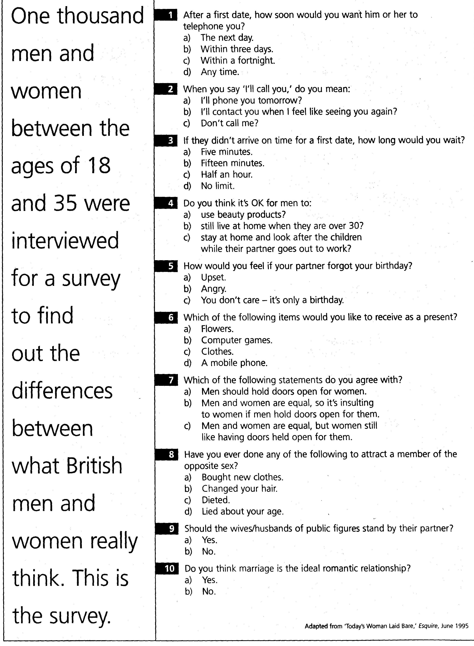

“BBC - Have your say” – Moderne LeserInnenbriefe

Beschreibung: LeserInnenbriefe bilden nach wie vor einen wichtigen Teil des Sprachunterrichts. SchülerInnen lernen in LeserInnenbriefen ihre eigene Meinung zu aktuellen Themen auszudrücken. Zeitungen wie BBC oder The Guardian haben inzwischen auch eine Online Form, von LeserInnenbriefen entwickelt, auf denen LeserInnen ohne großen Aufwand ihre Meinung zu einem Thema hinterlassen können.
Zeitaufwand: 30 min. Vorbereitung/30 min. Durchführung
Zielgruppe: Fortgeschrittene, Niveaustufen: B1 – C2
Lernziele: Schreiben üben, Kommentare lesen und verfassen, die eigene Meinung zu einem tagesaktuellen Thema ausdrücken
Vorbereitung:
Suchen Sie zunächst einen geeigneten „Have your say“ Beitrag auf BBC News bzw. erstellen Sie eine Kopiervorlage für die Arbeit im Klassenzimmer. Besuchen Sie dazu die Seite http://news.bbc.co.uk/2/hi/talking_point, um einen geeigneten Beitrag auszuwählen.

Durchführung:
Nachdem Sie auf BBC News einen geeigneten „Have your say“ Beitrag ausgewählt haben, teilen Sie den SchülerInnen die Internetadresse mit. Die SchülerInnen lesen zunächst in Einzelarbeit zwei bis drei Kommentare und hinterlassen daraufhin ihre eigenen Kommentare.

Neben der Möglichkeit, Kommentare direkt auf der Webseite zu hinterlassen, bietet sich auch die Alternative an, die Übung in Papierform mit ein oder zwei Kommentarbeispielen als Muster durchzuführen (s. Kopiervorlage) und als Hausübungsbeispiel SchülerInnen dann die redigierten Beiträge Online verfassen zu lassen. Die Alternative in Papierform eignet sich gut als Beispiel für Schularbeiten oder Maturaaufgaben.
Folgeübungen:
Als Vorübung kann das Thema „LeserInnenbriefe“ behandelt werden bzw. ein Nachrichtenbeitrag, der sich auf dasselbe Thema bezieht. Auf BBC News ist hier in der Regel eine Verlinkung zum entsprechenden Beitrag bereits angegeben.

Varianten:
BBC News hat inzwischen auch eine „Watch Have your say“ Video Variante eingerichtet. Die Videos können zum Beispiel als Input für Diskussionen zu gewissen Themen dienen.
Andere Zeitungen mit Online LeserInnenbriefen:
The Guardian - Comment is free: http://commentisfree.guardian.co.uk/index.html Auf dieser Seite besteht die Möglichkeit Kommentare zu hinterlassen, die von ModeratorInnen geprüft werden.
Standard: http://derstandard.at/meinung
Kommentare von LeserInnen und JournalistInnen übersichtlich auf einer Seite dargestellt. Im Deutschunterricht können Kommentare zu einem oder mehreren Themen ausgewählt werden.

Have Your Say

Instructions: Read the following “Have your say” and the comments supplied by the individual readers. Then write a comment of about 100 – 150 words of your own

Are dads as good as mums?
Dads are just as skilled as mums when it comes to parenting, yet the role of father is still seen as secondary by much of society. Send us your views.
New research launched by the Fatherhood Institute says fathers have a major impact on child welfare yet they spend on average a month less with their children than mums each year.
They are calling for a shake up of parental leave, and are encouraging all family professionals such as midwives and teachers to actively involve fathers.
Are fathers given a harder time as parents? Are mothers better at parenting because they are female? Are you a parent that believes parents are equal or do you think that fathers should work, whilst mothers are better at making a home?
Published: Tuesday, 8 January, 2008, 09:43 GMT 09:43 UK

Comments
Added: Tuesday, 8 January, 2008, 15:54 GMT 15:54 UK by [iwontdrinkthewater]
Both parents are equally important. Each parent has equal but different roles in the lives of their children. Whether certain responsibilities lie with the father or mother would depend largely on their individual character traits and on their particular circumstances. And no, I don't believe that women, by virtue of being female, are better at it - either that or I'm missing the requisite hormones!
Added: Tuesday, 8 January, 2008, 16:03 GMT 16:03 UK [John Hixley]
Yes, definitely. My partner and I work opposite hours so we both take on the childcare and the work equally. The children benefit from doing different things with each of us and I'm sure we both benefit too. I know lots of Dads who are hardly involved with their children and I think that's a bad thing. However, I do think that "male" jobs are less family friendly. My employer is fantastic but my partner's employer is very inflexible.
Source: http://news.bbc.co.uk/2/hi/talking_point/

Using Youtube in the EFL Classroom

I have been using Youtube videos frequently in EFL classrooms. I find some of the videos, especially the ones from news stations, extremely useful when trying to find video content for any given topic. The following examples show two short videos that deal with the topic of drugs (teenage inhalants) and can be used to stimulate discussion or as a warm-up activity to introduce the topic.

PSA Teenage Inhalants
The first one is a 60 second educational PSA regarding the dangers of inhalant abuse. The PSA was produced alongside the National Inhalant Prevention Coalition. For more information on the topic the pages below can help generate material or exercises:
Video URL: http://youtube.com/watch?v=vSWt8UMRsdY
www.inhalants.com
www.inhalant.org
http://www.nida.nih.gov/ResearchReports/Inhalants/Inhalants.html
13 ABC report teenage inhalants
The second video is a 4 minute in-depth report by Ronnie Dahl from 13 ABC Action News in Toledo, Ohio, regarding teens and the dangers of inhalant abuse. I used it with the set of questions below and to stimulate discussion.
Video comprehension questions
- What do kids call getting high computer duster?
- What are some of the products these teens use?
- Why is it so popular with younger kids?
- How many 8th graders use inhalants?
- What is dangerous about inhalants?
- What is said about the Williams family?
- What are some signs of using inhalants?
Vocabulary: To get a buzz

Video URL: http://youtube.com/watch?v=8LpFqVyx62o

Using Wikis to generate online group work

Wikis are a wonderful tool when organizing collaborative group work. They are wonderful when different groups need to e.g. research different aspects of a given topic. I used a Wiki in Moodle – which is easy to operate, if you have access to a moodle platform – to work on the topic of pop art.

Aim: To work in groups using wikis, to research the topic of pop art
Level: B2-C2 intermediate and above
Time: 120 minutes
Sites:
What is a Wiki and using Wikis http://www.oreillynet.com/pub/a/network/2006/07/07/what-is-a-wiki.html
Free wikis without advertisement: www.wikispaces,com

Procedure:
Start a wiki web page with the following topic entries:

1. WarholAndy
2. TheFactory
3. ThePopArtMovement
4. RoyLichtenstein
5. TheVelvetUnderground
6. ThemesOfPopArt
7. AmericanPopArt
8. Three British RepresentativesAndShortBios
9. MTVandAndyWarhol
10. AndyWarholAndFilms

Tell students to get together in groups of 2-3 students and research on one topic per group. Ask them to include at least 2 pictures and a link to a museum page, where pop art is featured. Tell them that they can spend abut 80 minutes on this task and will then have to give a short three minute presentation.
Follow-up: Have each group edit and correct the entry of another group.
Variation: This activity can be done with virtually any topic.

EVALUATION OF INTERNET PROJECT
Rubistar is a free tool to help teachers create quality rubrics at http://rubistar.4teachers.org
Assessment Rubric (wiki)
 | 1 | 2 | 3 | 4
Originality | Most, if not all, information on the wikipage has been cut and pasted from other websites. | Wikipage includes more information from other websites than from the student author. | Student composes wikipage and includes information from other sources that is properly quoted and cited. | Everything written on the wikipage is 100% your own words and ideas.
Knowledge & Understanding | Ideas lack clarity and detail. | Ideas are direct and usually clear. | Ideas are presented in a clear manner. Effectively conveys content. | Ideas are presented in engaging, polished, & thorough manner.
Graphics | Lacks images and pictures. | Few pictures or images throughout project. | Images and pictures covey additional information. | Images and pictures convey details of project and enhance understanding.
Citations | No way to check validity of information. Student does not list any sources where gathered information. | Much of the information, photos and graphics are not properly cited. | Most sources of information use proper citation and sources documented to check on the accuracy of information. | Information is properly cited so that the audience can determine the credibility and authority of the information presented.
Grammar, Usage & Mechanics | Many errors distract audience. | Some errors in spelling, punctuation, or capitalization. | Few errors in spelling, punctuation, or capitalization. | No errors in spelling, punctuation, or capitalization.
Craftsmanship | Limited clarity and thought; unsophisticated final product. | Direct and clear project; lacks creative flare. | Creative craftsmanship of final product. | Original and unique craftsmanship of final product.
Project  Components | Missing two or more elements of the wiki project components. Project elements lacks details and/or correct information. | Missing one or two elements of the wiki project requirements. | Includes all necessary pieces of wiki-project (biography, top albums, why in top 50, and contributions to rock and roll). | Thorough and descriptive information included in all components of wiki project.
Use of Class Time | Class time was not used wisely and the student put no effort in creating project. | Class time was not always used wisely, but student showed some effort in creating project. | Used class time wisely. Student could have put in more effort into executing design of project. | Class time used wisely. Time and effort put into the planning and designing project.

BLOG PROJECT PLANNING SHEET

documentation
Contact:
Martin Sankofi: sankofi@gmx.net
Petra Szucsich: szucsich@aon.at

Links mentioned:
http://delicio.us/msankofi/dis

Presentation:
www.slideshare.net

Handouts:
http://szucsich.sankofi.com/dis

